Bubble Sort
Bubble sort is a brute-force application of sorting problems which is to compare adjacent elements of the list and exchange them if they are out of order. By doing it repeatedly, we end up “bubbling up” the largest element to the last position on the list. The next pass bubbles up the second largest element, and so on, until after n − 1 passes the list is sorted. Pass i (0 ≤ i ≤ n − 2) of bubble sort can be represented by the following diagram:
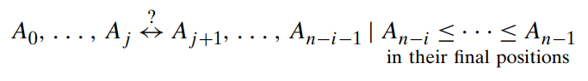

The basic operation here is key comparison,
A[j+1]<A[j].

ALGORITHM BubbleSort(A[0..n − 1])
//Sorts a given array by bubble sort
//Input: An array A[0..n − 1] of orderable elements
//Output: Array A[0..n − 1] sorted in nondecreasing order
for i ← 0 to n − 2 do
for j ← 0 to n − 2 − i do
if A[j + 1] < A[j ]
swap A[j ] and A[j + 1]

The action of the bubble sort algorithm on the list 89, 45, 68, 90, 29, 34, 17 is illustrated as an example.

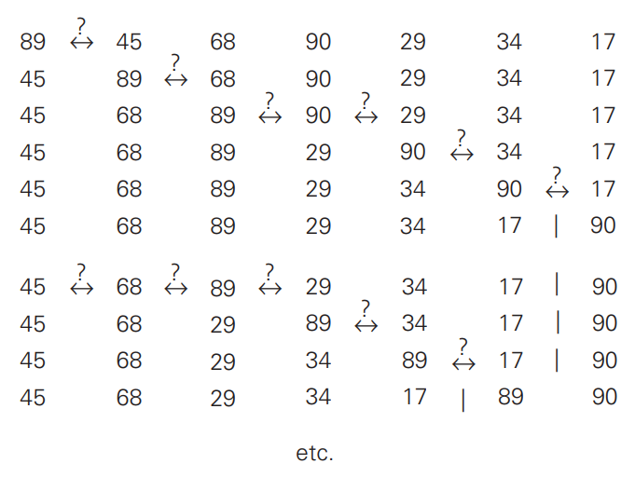

The number of times, the basic operation is executed depends only on the array size and is given by,

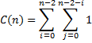
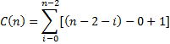
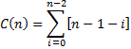

The number of key swaps however, depends on the input. For the worst case, if the elements are in decreasing arrays, it is same as number of key comparisons. Therefore,

